|  |  |  |  |  |  |
| --- | --- | --- | --- | --- | --- |
| Date | 12-Dec-22 | | | Tester Name | Richard Belanger |
| Environment | Penfax - Test | | | Login used | TEST2 |
| Operating System | Windows | Version: | Update: | | |
| Software Used | Edge | Version: | Update: | | |
| Not Applicable | Version: | Update: | | |
| Release version | 22.4.1 | | | | |
| Title | M51.05 Tax Slip Batch - Ad-hoc Batch | | | | |
| Test Type | Regression | | | | |
| Test Scenario | Create a payment and run the Tax slip for that member | | | | |
|  |  | | | | |
| Expected Results | Tax slip will create | | | | |
| Pass/Fail | Pass | | | JIRA# | N/A |

Describe your steps with screenshots:

Payment created

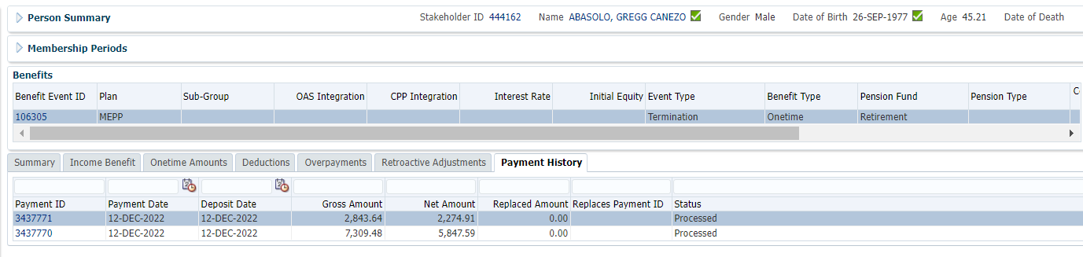

and Ad Hoc T4A run was finished

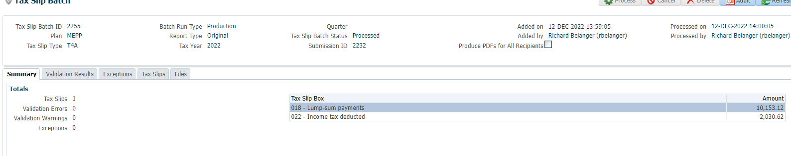

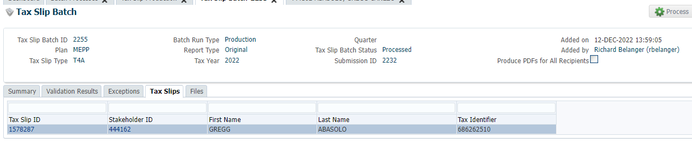

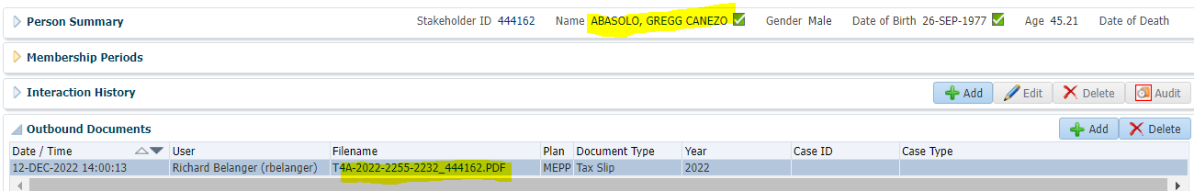

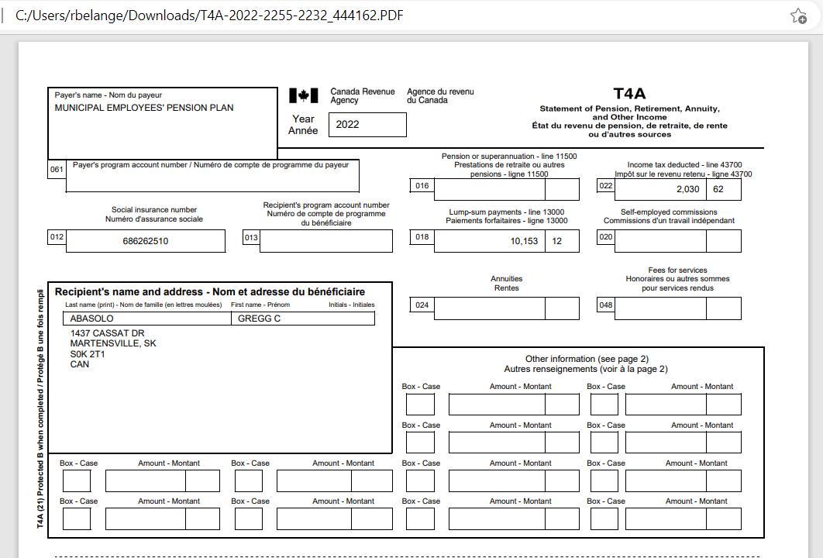

Total Payment is 2843.64 + 7309.48 = $10,153.12

Tax Rates

0.00-4,999.99 = 10%

5,000.00- 14,999.99 = 20%

15,000.00+ = 30%

Taxed at 20%, 10,153.12 x 20% = 2,030.62; 10,153.12 – 2,030.62 = $8,122.50

Tax taken = $2,030.62